

**CSIS 3003**

**PROJECT I**

**Game Trade - Second-Hand Game Disc Purchasing, Selling, Rent, and Exchange Management System (Stage 2)**

**Wong Yik Khen (D170325B)**

**Wong Juin Zheng (D170231B)**

**Ng Weng Kang (D170264B)**

**Lecturer: Mr. So Yong Quay**

**25th May 2018**

**Department of Computer Science**

**Faculty of Engineering and Information Technology**

Table of Contents

1.0 DFD Diagram

1.1 Context level ……………………………………………………………………...1

1.2 DFD Diagram ……………………………………………………………………. 2

1.3 DFD Diagram 1

1.3.1 Customer subsystem……………………………………………………. 3

1.3.2 Purchase order system………………………………………………….. 4

1.3.3 Sales order system……………………………………………………… 5

1.3.4 Payment system………………………………………………………… 6

1.3.5 Administrator system……………………………………………………7

1.3.6 Report system…………………………………………………………... 8

2.0 ER Diagram………………………………………………………………………………..9

3.0 Class Diagram……………………………………………………………………………10

4.0 Use case diagram

4.1 Customer subsystem……………………………………………………………...11

4.2 Purchase order system……………………………………………………………12

4.3 Payment System………………………………………………………………….13

4.4 Report System……………………………………………………………………14

4.5 Sales order system………………………………………………………………..14

4.6 Administrator System…………………………………………………………….15

5.0 Use case description

5.1 Customer subsystem………………………………………………………..…….16

5.2 Purchase order system…………………………………………………….……...24

5.3 Payment System………………………………………………………….………32

5.4 Report System…………………………………………………………….……...37

5.5 Administrator System……………………………………………………..……...41

5.6 Sales order system…………………………………………….…………….……46

6.0 Activity Diagram

6.1 Customer subsystem………………………………………..………………….....52

6.2 Purchase order system……………………………………………………………53

6.3 Payment System…………………………………………….……………………54

6.4 Report System……………………………………………………………………55

6.5 Sales order system………………………………………………………………..56

6.6 Administrator System…………………………………………………………….57

7.0 Sequence Diagram

7.1 Customer subsystem………………………………………………………...……58

7.2 Purchase order system………………………………………………………..60

7.3 Payment System……………………………………………………...………61

7.4 Report System……………………………………………………..…………63

7.5 Sales order system………………………………………………………………..64

7.6 Administrator System………………….…………………………………………65

1.0 DFD Diagram

1.1 Context level

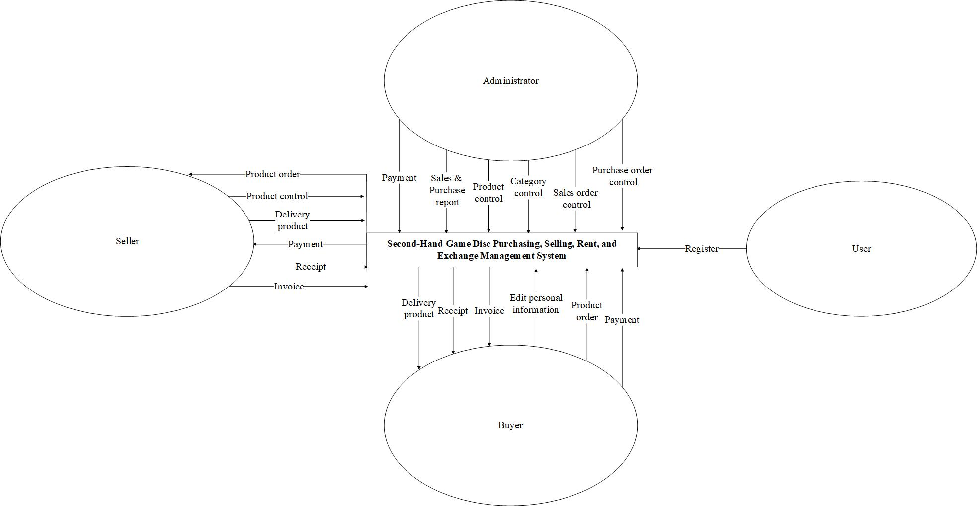

1.2 DFD Diagram level 0

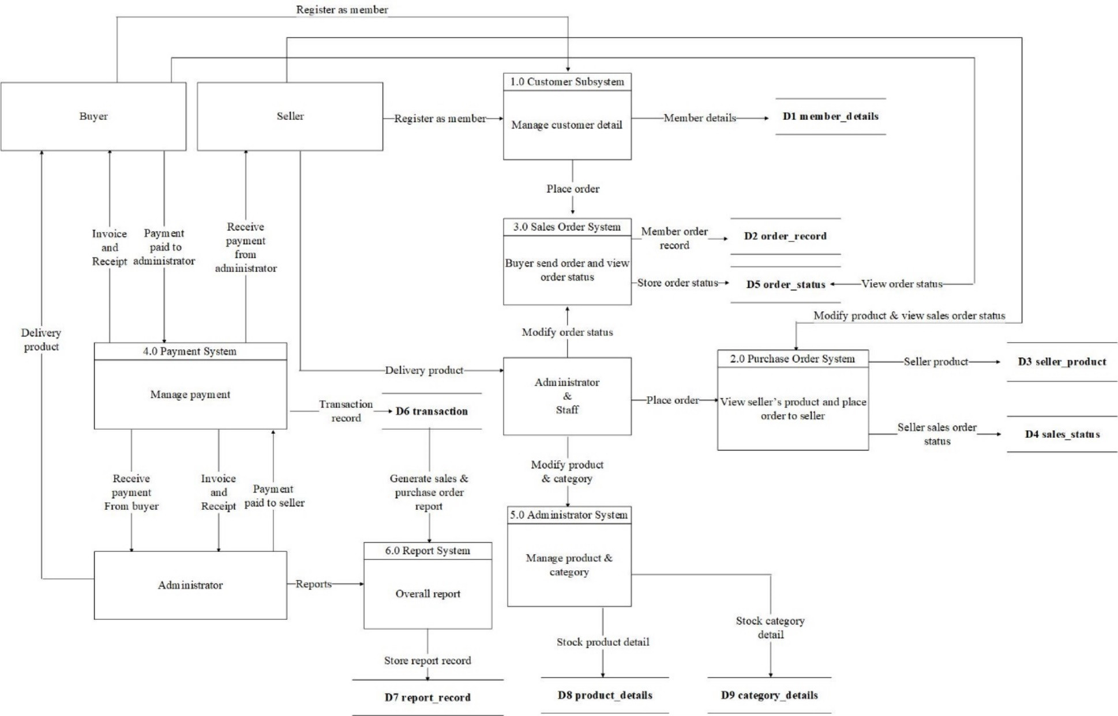

1.3 DFD Diagram level 1

1.3.1 Customer subsystem

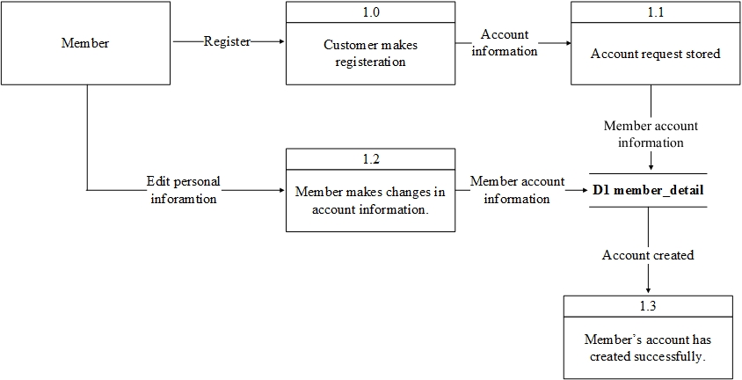

1.3.2 Purchase order system

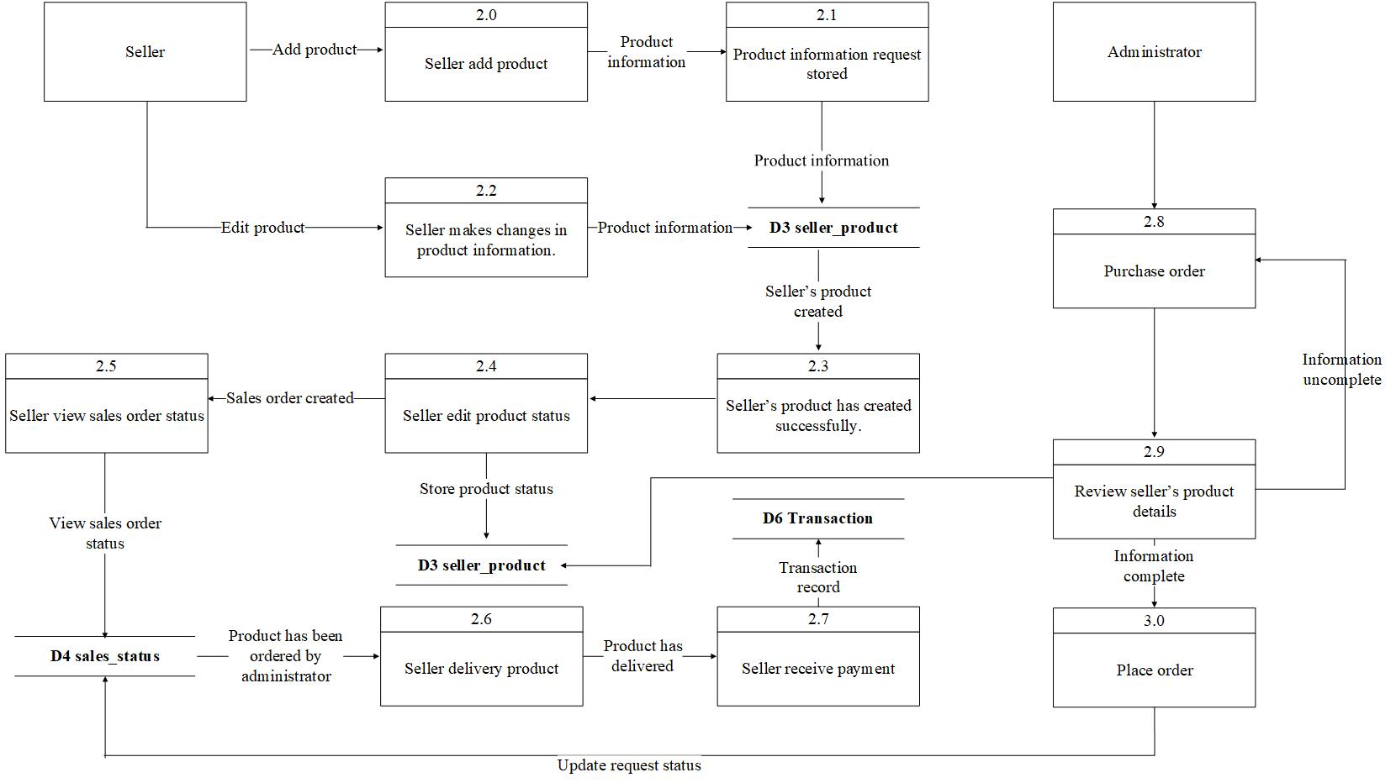

1.3.3 Sales Order System

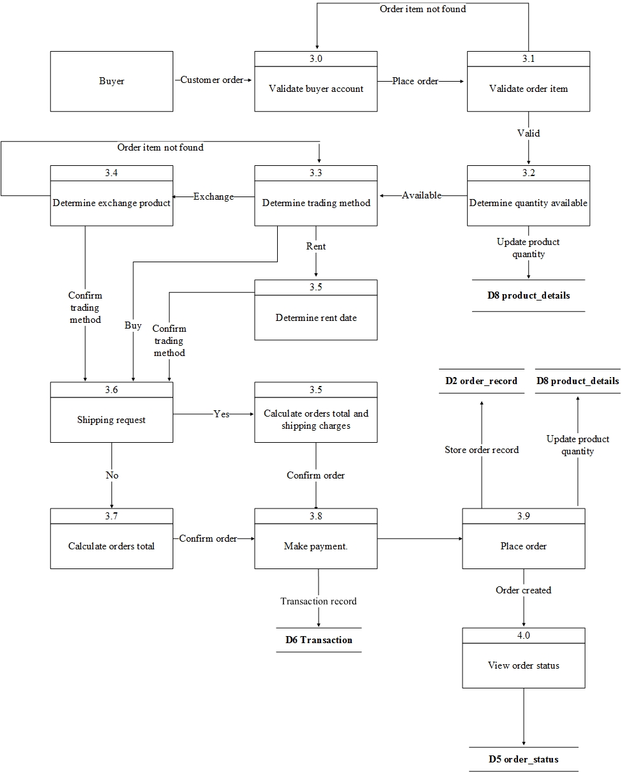

1.3.4 Payment System

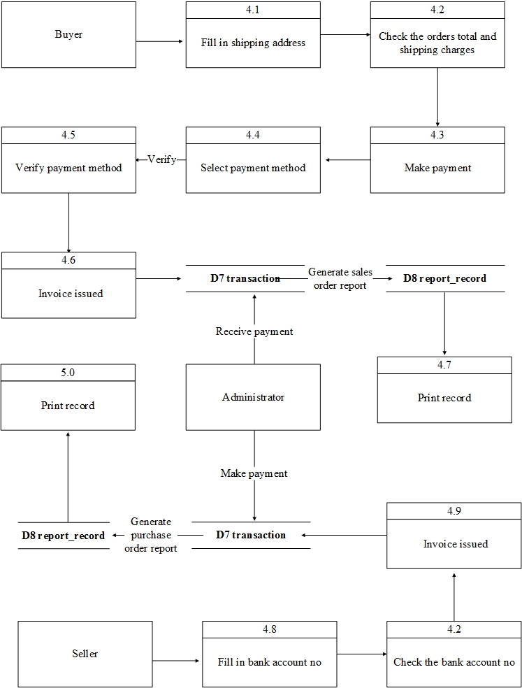

1.3.5 Administrator System

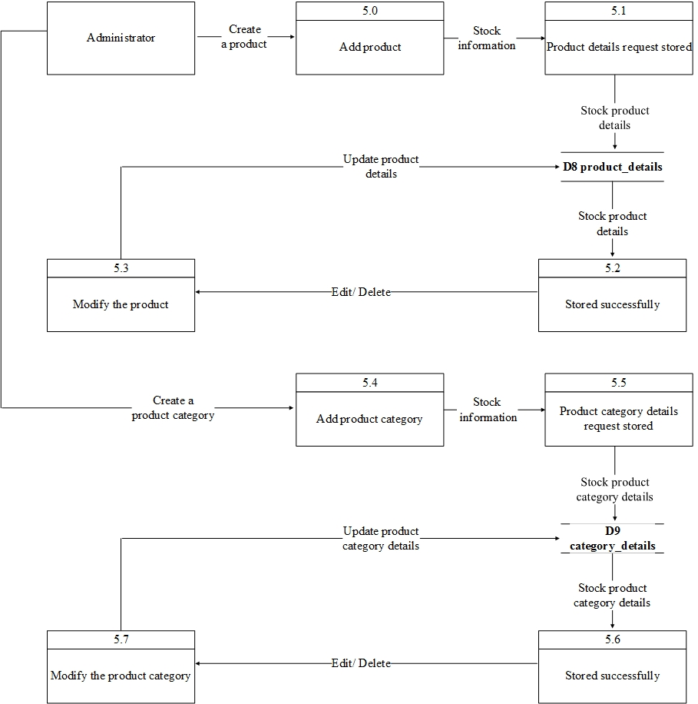

1.3.6 Report System

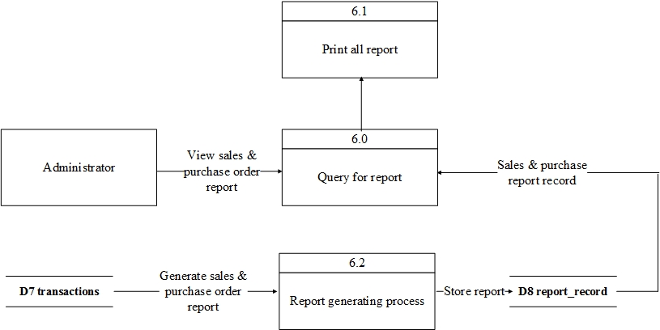

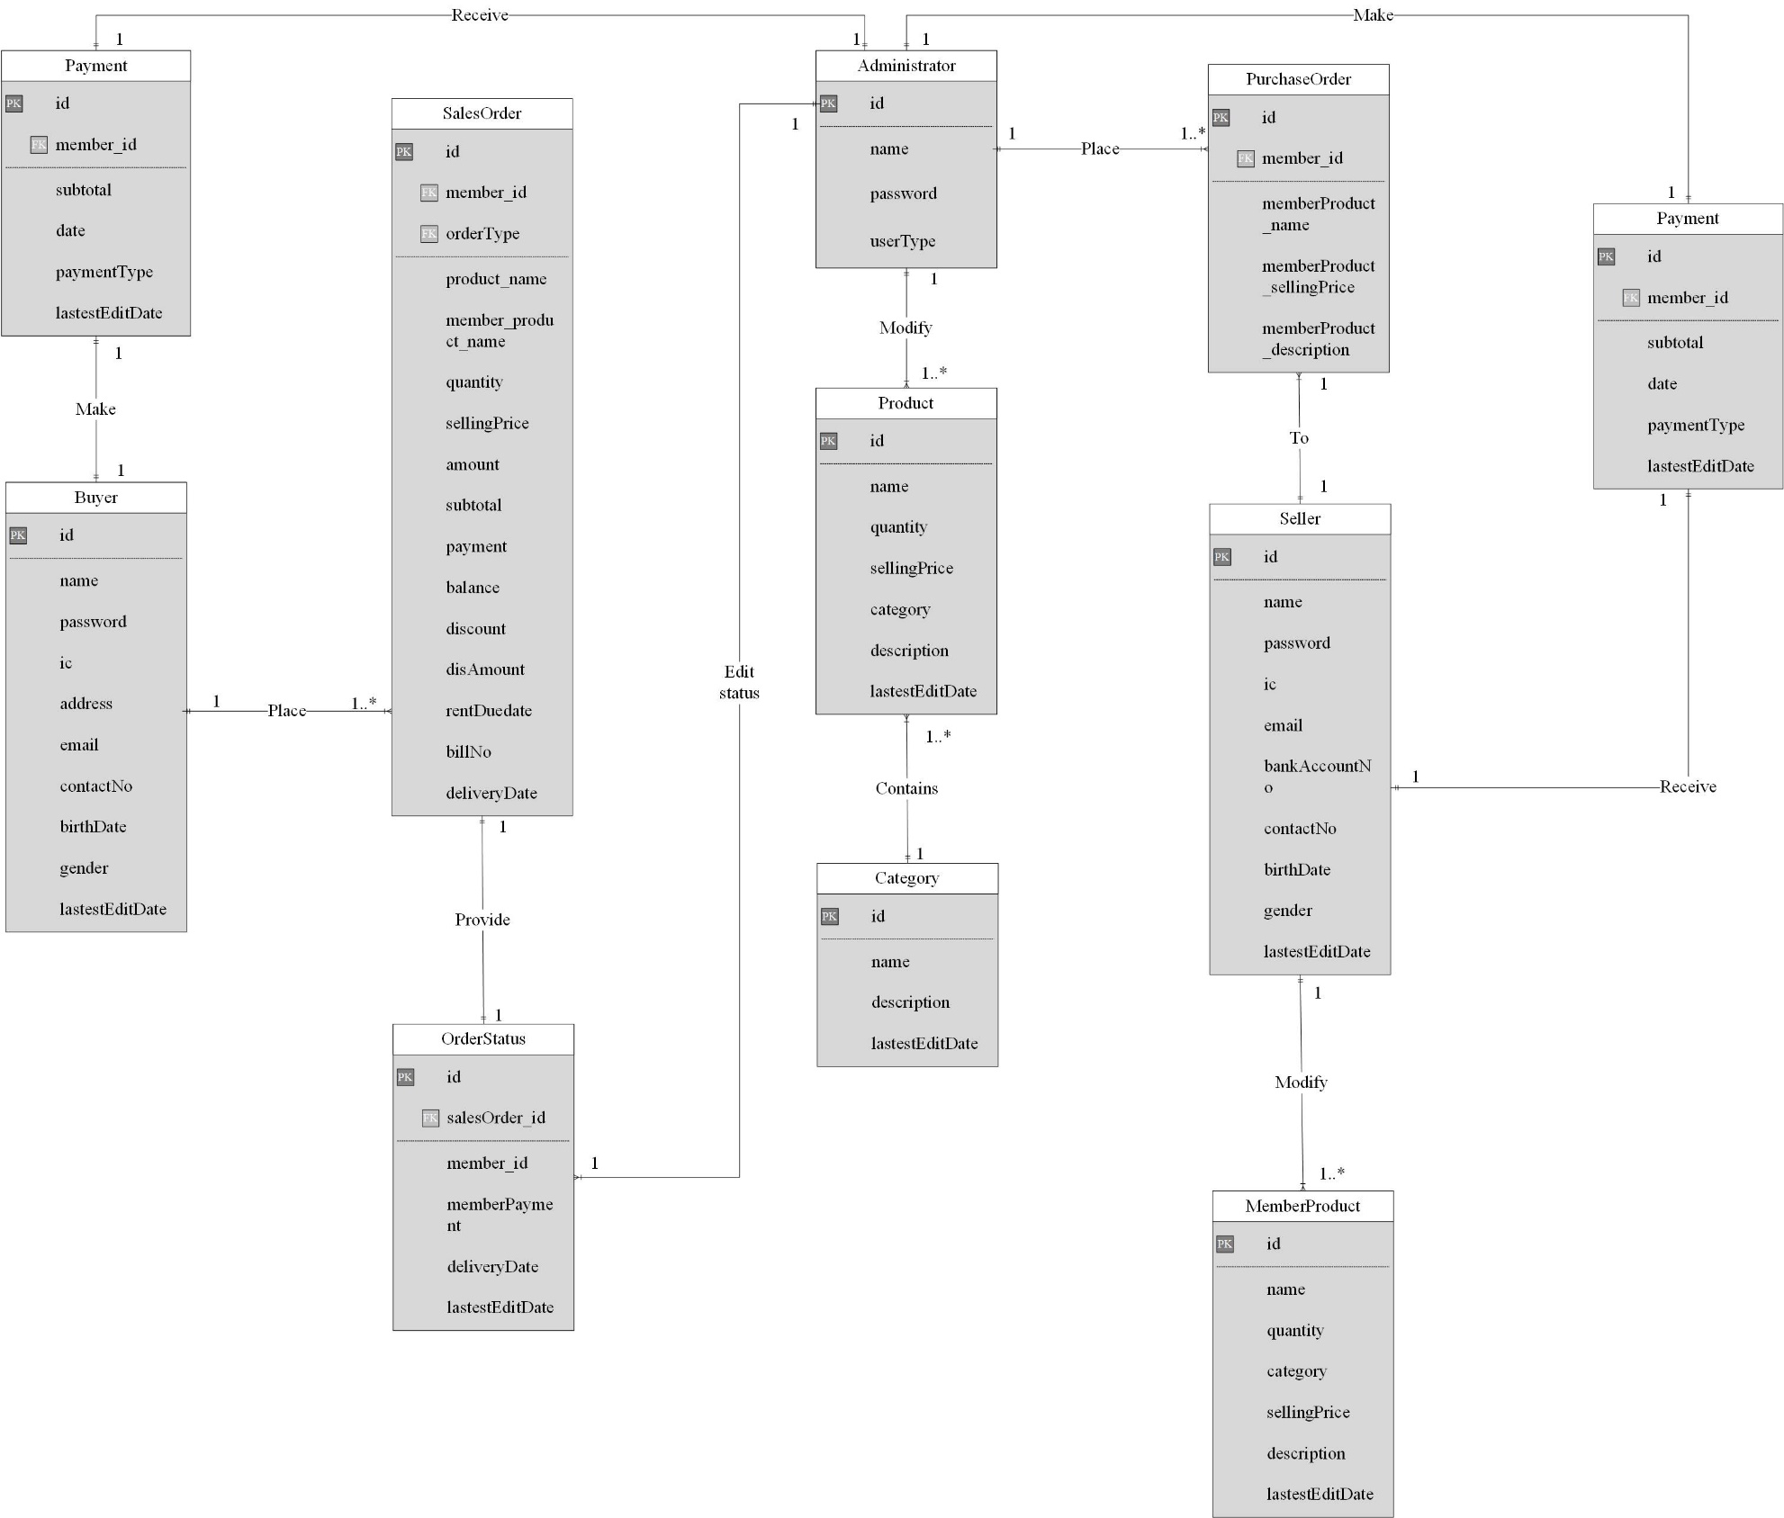2.0 ER diagram

3.0 Class diagram

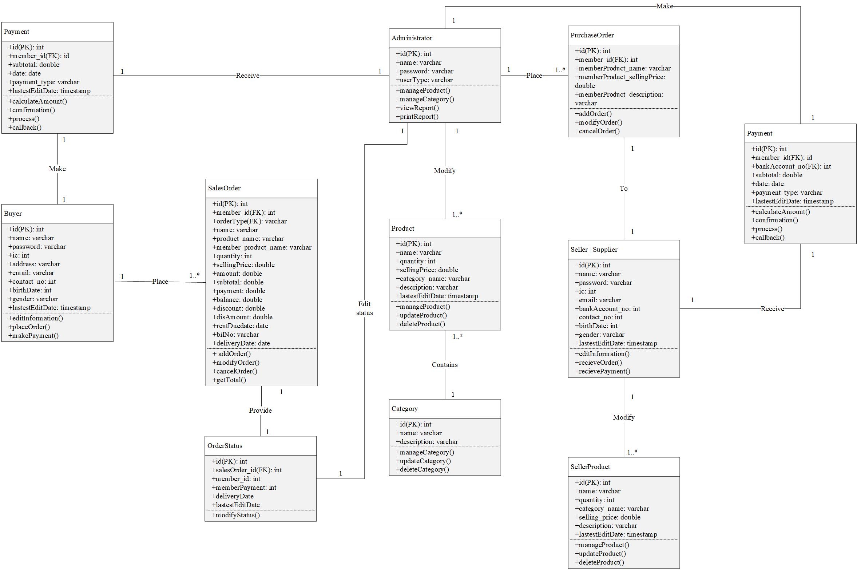

4.0 Use case diagram

4.1 Customer subsystem

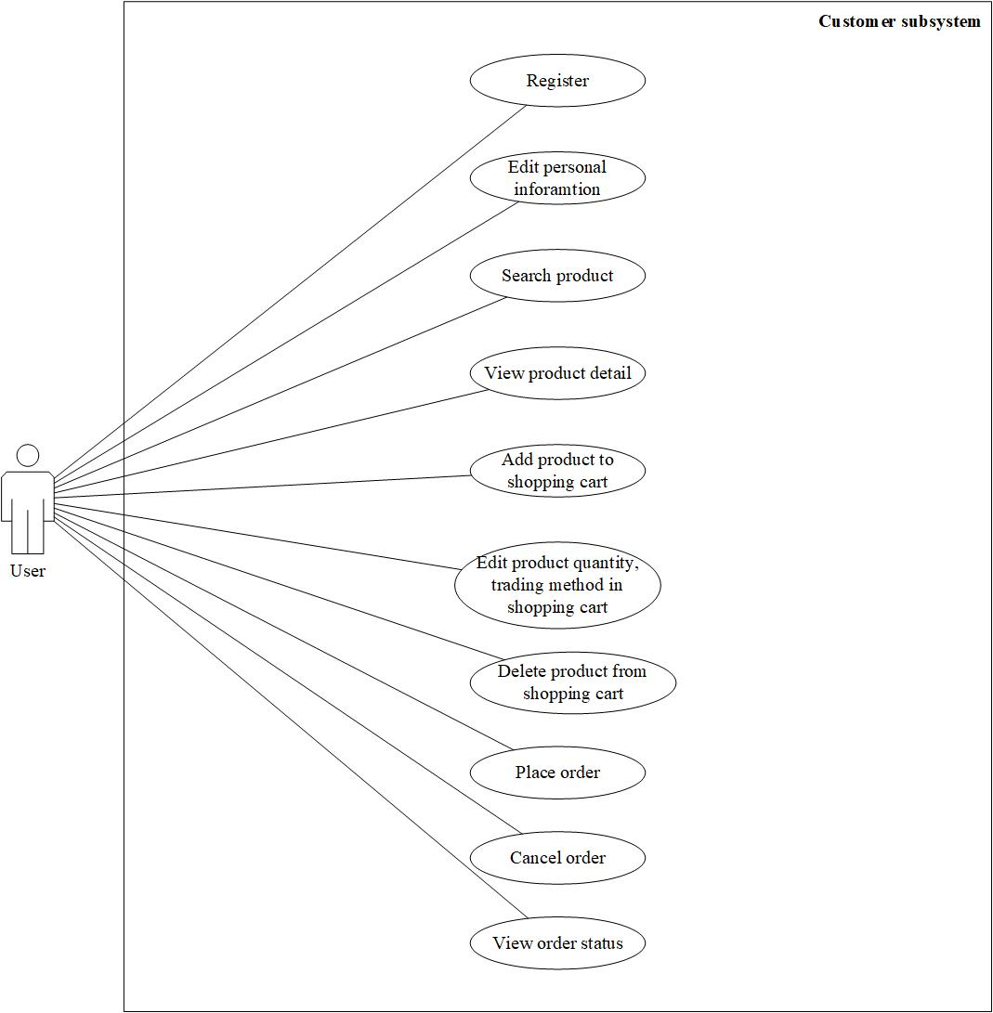

4.2 Purchase order system

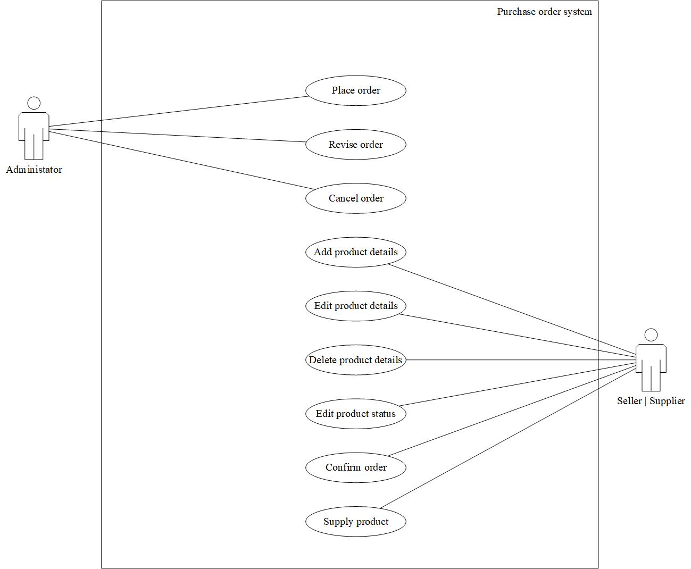

4.3 Payment system

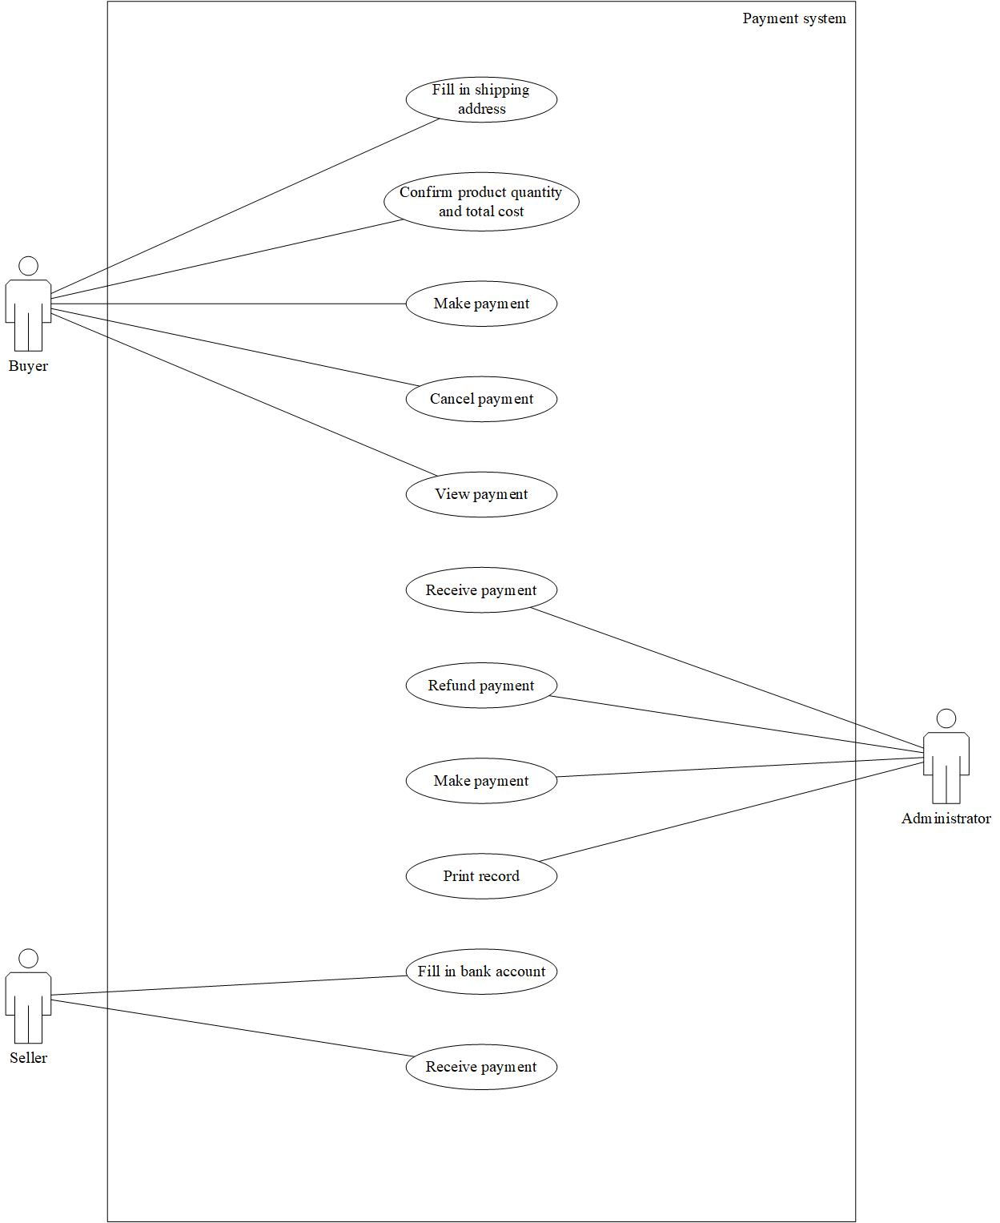

4.4 Report system

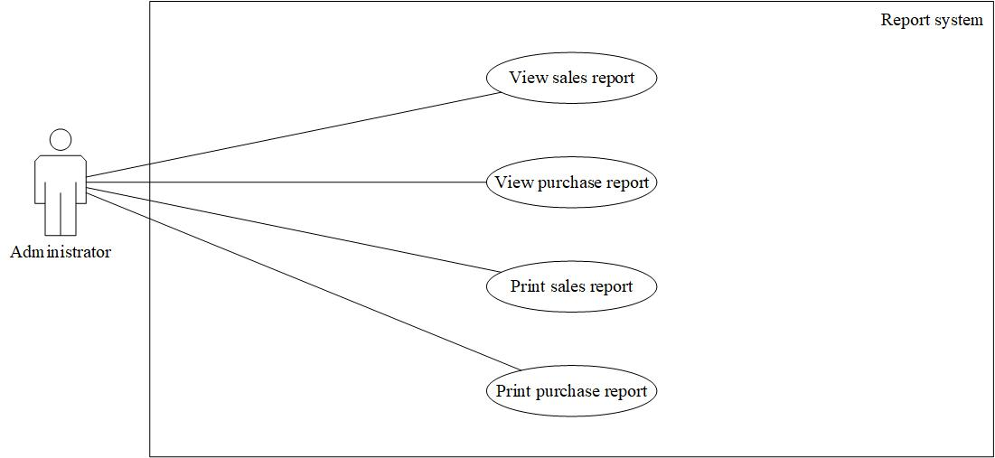4.5 Administrator system

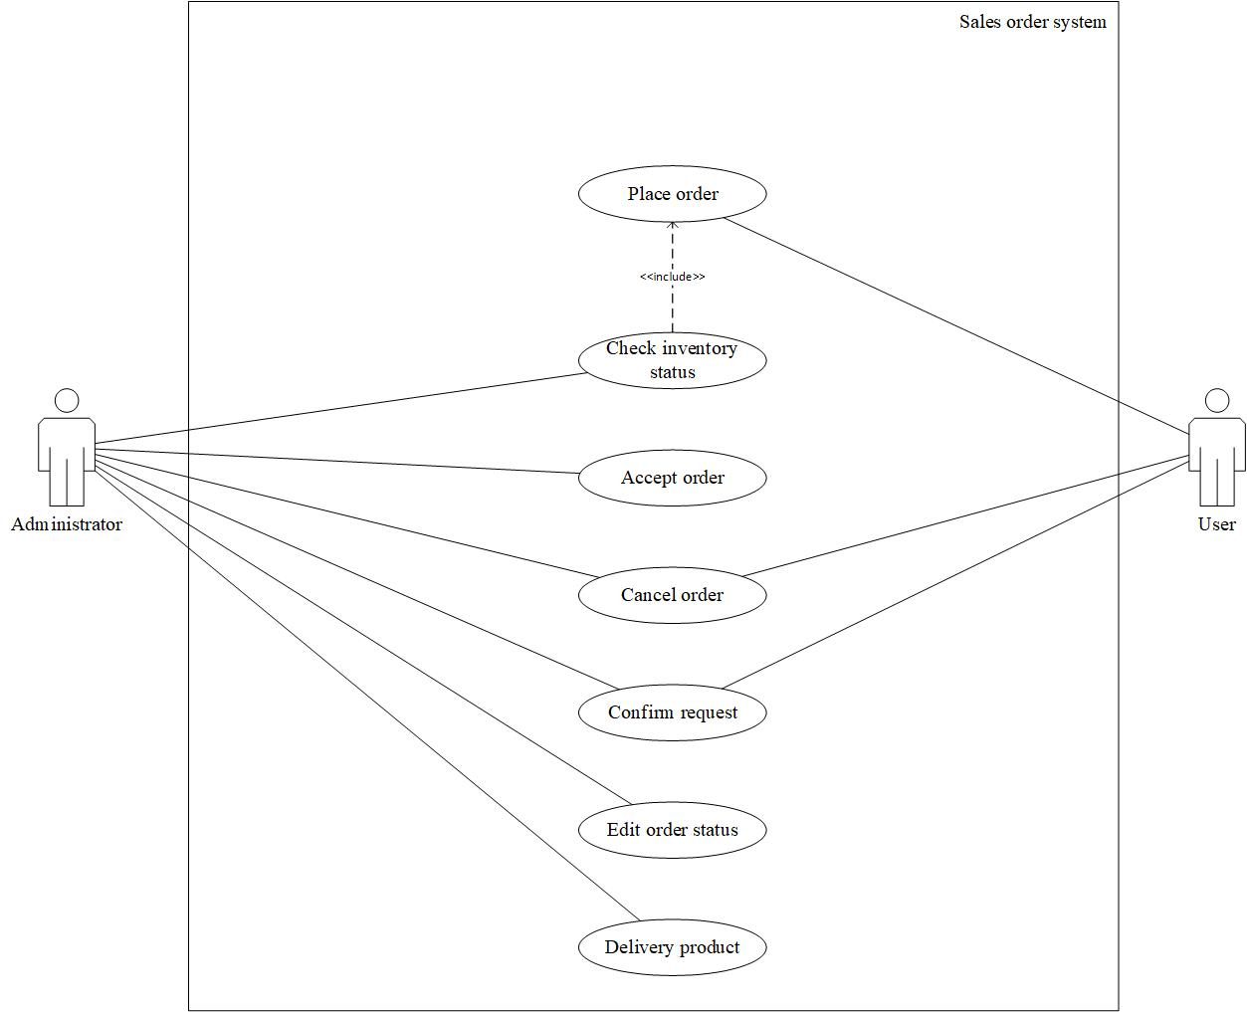

4.6 Sales Order system

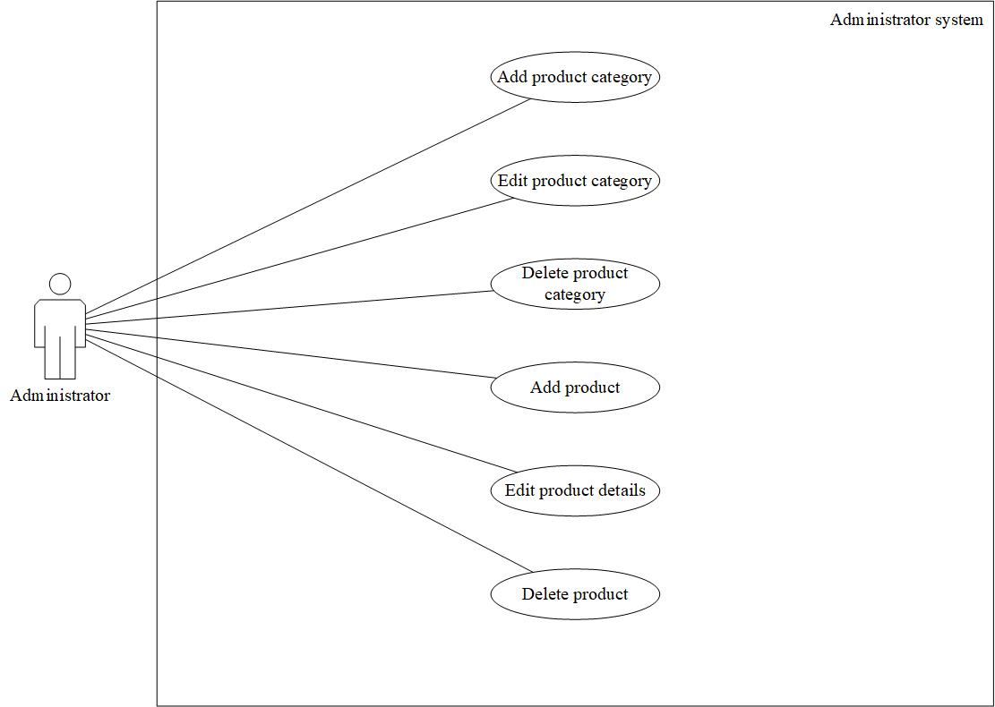

5.0 Use case description

5.1 Customer subsystem

|  |  |  |
| --- | --- | --- |
| **Use case: Register as member (Customer subsystem)** | | |
| Overview: This case describes how register as a member. | | |
| Pre-conditions: - | | |
| Post conditions:   1. Successful condition  * User has registered as a member and member account is created. | | |
| Event | | Response |
| 1 | User enters to the webpage system. | * Different available alternative displayed. |
| 2 | Enter all the required information. | * Perform information validation. |
| 3 | User register successfully. | * User account is created. * Return to the main page. |
| Extensions | | |
| 1 | Invalid webpage. | * Message “The requested URL was not * found on this server. Please try again” displayed. |
| 1 | Unable to display webpage content. | * Message “Web page is under construction. * Please try again later.” |
| 2 | Invalid information. | * Display warning message to reject the details. * Request to re-enter the details. |

|  |  |  |
| --- | --- | --- |
| **Use case: Edit information (Customer subsystem)** | | |
| Overview: This case describes how the user edit personal information. | | |
| Pre-conditions:   1. The login user must be member. | | |
| Post conditions:   1. Successful condition  * Member has update their personal information successfully. | | |
| Event | | Response |
| 1 | Member login to the webpage. | * Perform user account validation. * Different available alternative displayed. |
| 2 | Member select user icon from website in navigation bar. | * Different available alternative displayed. |
| 3 | Member select user options. | * Different available alternative displayed. |
| 4 | Member click on edit button. | - |
| 5 | Edit the personal information. | * Perform information validation. |
| 6 | Member has updated the information successfully. | * Updated successfully. * Return to the user page. |
| Extensions | | |
| 1 | Invalid user account. | * Message “Invalid Account/Wrong password – please try again” displayed. |
| 5 | Invalid information. | * Prompt alert box “Invalid information please try again.” * Resume step 5. |

|  |  |  |
| --- | --- | --- |
| **Use case: Search product (Customer subsystem)** | | |
| Overview: This case describes how the member search the product. | | |
| Pre-conditions:   1. The login user must be member. | | |
| Post conditions:   1. Successful condition  * Member has view the product successfully. | | |
| Event | | Response |
| 1 | Member login to the webpage. | * Perform user account validation. * Different available alternative displayed. |
| 2 | Member using search bar from website in navigation bar to search product. | * Different available alternative displayed. |
| 3 | Member has search product  successfully. | - |
| Extensions | | |
| 1 | Invalid user account. | * Message “Invalid Account/Wrong password – please try again” displayed. |
| 2 | Invalid request. | * Close session. * Resume Homepage. |

|  |  |  |
| --- | --- | --- |
| **Use case: Add product to shopping cart (Customer subsystem)** | | |
| Overview: This case describes how the member add product to shopping cart. | | |
| Pre-conditions:   1. The login user must be member. | | |
| Post conditions:  1. Successful condition   * Member has added product to shopping cart successfully. | | |
| Event | | Response |
| 1 | Member login to the webpage. | * Perform user account validation. * Different available alternative displayed. |
| 2 | Member using search bar from website in navigation bar to search product. | * Different available alternative displayed. |
| 3 | Member click on buy button. | - |
| 4 | The selected product has sent to the shopping cart successfully. | * Product sent to the shopping cart successfully. |
| Extensions | | |
| 1 | Invalid user account. | * Message “Invalid Account – please try * again” displayed. |
| 3 | Invalid request. | * Close session. * Resume step 2. |

|  |  |  |
| --- | --- | --- |
| **Use case: View product detail (Customer subsystem)** | | |
| Overview: This case describes how the member view the product detail. | | |
| Pre-conditions:   1. The login user must be member. | | |
| Post conditions:   1. Successful condition  * Member has view the product detail successfully. | | |
| Event | | Response |
| 1 | Member login to the webpage. | * Perform user account validation. * Different available alternative displayed. |
| 2 | Member using search bar from website in navigation bar to search product. | * Different available alternative displayed. |
| 3 | Member click on detail button on selected product UI. | - |
| 4 | The selected product’s detail is viewing by member successfully. | * Product’s detail is viewing by member successfully. |
| Extensions | | |
| 1 | Invalid user account. | * Message “Invalid Account/Wrong password – please try again” displayed. |

|  |  |  |
| --- | --- | --- |
| **Use case: Place order (Customer subsystem)** | | |
| Overview: This case describes how the member place an order. | | |
| Pre-conditions:   1. The login user must be member. | | |
| Post conditions:   1. Successful condition  * Member has place order successfully. | | |
| Event | | Response |
| 1 | Member login to the webpage. | * Perform user account validation. * Different available alternative displayed. |
| 2 | Member select shopping cart from website in navigation bar. | * Different available alternative displayed. |
| 3 | Member select shopping cart options. | * Different available alternative displayed. |
| 4 | Select quantity, method of purchase, or remove from the shopping cart. | * Perform information validation. |
| 5 | Member click on order button. | - |
| 6 | Order created and sent to the administrator successfully. | * Order is created successfully. * Return to the shopping cart page. |
| Extensions | | |
| 1 | Invalid user account. | * Message “Invalid Account – please try * again” displayed. |
| 4 | Invalid input. | * Display warning message to reject the input. Request to re-enter the input. |
| 5 | Invalid request. | * Close session. * Resume step 4. |

|  |  |  |
| --- | --- | --- |
| **Use case: Cancel order (Customer subsystem)** | | |
| Overview: This case describes how the member cancel an order. | | |
| Pre-conditions:   1. The login user must be member. 2. Member has place order successfully. | | |
| Post conditions:   1. Successful condition  * Member has cancel the order successfully. | | |
| Event | | Response |
| 1 | Member login to the webpage. | * Perform user account validation. * Different available alternative displayed. |
| 2 | Member select shopping cart from website in navigation bar. | * Different available alternative displayed. |
| 3 | Member select order history options. | * Different available alternative displayed. |
| 4 | Member select an order. | - |
| 5 | Member click on cancel button. | - |
| 6 | Member cancel the order successfully | * The order is cancel successfully. * Return to order history page. |
| Extensions | | |
| 1 | Invalid user account. | * Message “Invalid Account – please try again” displayed. |
| 5 | Invalid request. | * Close session. * Resume step 4. |

|  |  |  |
| --- | --- | --- |
| **Use case: View order status (Customer subsystem)** | | |
| Overview: This case describes how the member view the order status. | | |
| Pre-conditions:   1. The login user must be member. 2. Member has place order successfully. | | |
| Post conditions:   1. Successful condition  * Member has viewed order status successfully. | | |
| Event | | Response |
| 1 | Member login to the webpage. | * Perform user account validation. * Different available alternative displayed. |
| 2 | Member select shopping cart from website in navigation bar. | * Different available alternative displayed. |
| 3 | Member select order history options. | * Different available alternative displayed. |
| 4 | Member select an order. | - |
| 5 | Member has view order status successfully. | * Order status has viewed successfully. |
| Extensions | | |
| 1 | Invalid user account. | * Message “Invalid Account/Wrong password – please try again” displayed. |

5.2 Purchase order system

|  |  |  |
| --- | --- | --- |
| **Use case: Place order (Purchase order system)** | | |
| Overview: This case describes how the administrator place an order. | | |
| Pre-conditions:  1.The login user must be administrator. | | |
| Post conditions:  1. Successful condition   * + Administrator has placed order successfully. | | |
| Event | | Response |
| 1 | Administrator login to the system. | * Perform user account validation. * Different available alternative displayed. |
| 2 | Administrator select purchase management system. | * Different available alternative displayed. |
| 3 | Administrator select add purchase order. | * Prompt place order UI. |
| 4 | Enter all the required information. | * Perform information validation. |
| 5 | Order created successfully. | * New Purchase order is created successfully. |
| Extensions | | |
| 1 | Invalid user account. | * Message “Invalid Account/Wrong password – please try again” displayed. |
| 4 | Invalid information. | * Display warning message to reject the details. * Request to re-enter the details. |

|  |  |  |
| --- | --- | --- |
| **Use case: Revise order (Purchase order system)** | | |
| Overview: This case describes how the administrator revise an order. | | |
| Pre-conditions:  1.The login user must be administrator. | | |
| Post conditions:  1. Successful condition   * + Administrator has revise the order successfully. | | |
| Event | | Response |
| 1 | Administrator login to the system. | * Perform user account validation. * Different available alternative displayed. |
| 2 | Administrator select Purchase order system. | * Different available alternative displayed. |
| 3 | Administrator select view Purchase order. | - |
| 4 | Administrator select an order | - |
| 5 | Administrator edit the order information. | * Perform information validation. |
| 6 | Administrator revise the order successfully. | * The order is updated successfully. * Return to Purchase order system. |
| Extensions | | |
| 1 | Invalid user account. | * Message “Invalid Account/Wrong password – please try again” displayed. |
| 5 | Invalid information. | * Prompt alert box “Invalid information – please try again.” * Request to re-enter the details. |

|  |  |  |
| --- | --- | --- |
| **Use case: Cancel order (Purchase order system)** | | |
| Overview: This case describes how the administrator cancel an order. | | |
| Pre-conditions:  1.The login user must be administrator. | | |
| Post conditions:  1. Successful condition   * + Administrator has cancel the order successfully. | | |
| Event | | Response |
| 1 | Administrator login to the system. | * Perform user account validation. * Different available alternative displayed. |
| 2 | Administrator select Purchase order system. | * Different available alternative displayed. |
| 3 | Administrator select view Purchase order. | - |
| 4 | Administrator select an order | - |
| 5 | Administrator cancel the order. | * Perform information validation. |
| 6 | Administrator cancel the order successfully. | * The order is cancel successfully. * Return to Purchase order system. |
| Extensions | | |
| 1 | Invalid user account. | * Message “Invalid Account/Wrong password – please try again” displayed. |
| 5 | Invalid information. | * Close session. • * Resume step 3 |

|  |  |  |
| --- | --- | --- |
| **Use case: Add product (Purchase order system)** | | |
| Overview: This case describes how the member add the product. | | |
| Pre-conditions:  1.The login user must be member. | | |
| Post conditions:  1.Successful condition   * Member has added the product successfully. | | |
| Event | | Response |
| 1 | Member login to the webpage. | * Perform user account validation. * Different available alternative displayed. |
| 2 | Member select user icon from website in navigation bar. | - |
| 3 | Member select product options. | * Different available alternative displayed. |
| 4 | Member click on add product button. | - |
| 5 | Add the product detail. | * Perform detail validation. |
| 6 | Member add product successfully. | * Add successfully. * Return to the product page. |
| Extensions | | |
| 1 | Invalid user account. | * Message “Invalid Account/Wrong password – please try again” displayed. |
| 5 | Invalid details. | * Display warning message to reject the details. Request to re-enter the details. |
| 5 | Invalid units. | * Display warning message to reject the prices. Request to re-enter the prices. |

|  |  |  |
| --- | --- | --- |
| **Use case: Edit product (Purchase order system)** | | |
| Overview: This case describes how the member edit their product information. | | |
| Pre-conditions:   1. The login user must be member. 2. Administrator has added product successfully. | | |
| Post conditions:   1. Successful condition  * Administrator has updated their product information successfully. | | |
| Event | | Response |
| 1 | Member login to the webpage. | * Perform user account validation. * Different available alternative displayed. |
| 2 | Member select user icon from website in navigation bar. | - |
| 3 | Member select product options. | * Different available alternative displayed. |
| 4 | Member click on edit button. | - |
| 5 | Edit the product information. | * Perform information validation. |
| 6 | Member edit product successfully. | * Edit successfully. * Return to the product page. |
| Extensions | | |
| 1 | Invalid user account. | * Message “Invalid Account/Wrong password – please try again” displayed. |
| 5 | Invalid information. | * Prompt alert box “Invalid information please try again.” * Resume step 5. |

|  |  |  |
| --- | --- | --- |
| **Use case: Delete product (Purchase order system)** | | |
| Overview: This case describes how the member delete their product information. | | |
| Pre-conditions:   1. The login user must be member. 2. Member has added product successfully. | | |
| Post conditions:   1. Successful condition  * Member has deleted their product information successfully. | | |
| Event | | Response |
| 1 | Member login to the webpage. | * Perform user account validation. * Different available alternative displayed. |
| 2 | Member select user icon from website in navigation bar. | - |
| 3 | Member select product options. | * Different available alternative displayed. |
| 4 | Member click on delete product button. | - |
| 5 | Delete the product information. | * Prompt confirmation box “Do you want to delete this product?” |
| 6 | Member has deleted the product successfully. | * Deleted successfully. * Return to the product page. |
| Extensions | | |
| 1 | Invalid user account. | * Message “Invalid Account/Wrong password – please try again” displayed. |
| 5 | Invalid request. | * Close session. * Resume step 4. |

|  |  |  |
| --- | --- | --- |
| **Use case: Edit product status (Purchase order system)** | | |
| Overview: This case describes how the member edit product status. | | |
| Pre-conditions:   1. The login user must be member. 2. Member has added product successfully. | | |
| Post conditions:   1. Successful condition  * Member has place request successfully. | | |
| Event | | Response |
| 1 | Member login to the webpage. | * Perform user account validation. * Different available alternative displayed. |
| 2 | Member select user icon from website in navigation bar. | - |
| 3 | Member select product options. | * Different available alternative displayed. |
| 4 | Member select a product. | * Different available alternative displayed. |
| 5 | Member click on sell button. | - |
| 6 | Request created and sent to the administrator successfully. | * New request is created successfully. * Return to the product page. |
| Extensions | | |
| 1 | Invalid user account. | * Message “Invalid Account – please try * again” displayed. |

|  |  |  |
| --- | --- | --- |
| **Use case: Confirm request (Purchase order system)** | | |
| Overview: This case describes how the member confirm order. | | |
| Pre-conditions:   1. The login user must be member. | | |
| Post conditions:   1. Successful condition  * Member has confirmed the order successfully. | | |
| Event | | Response |
| 1 | Member login to the webpage. | * Perform user account validation. * Different available alternative displayed. |
| 2 | Member select user icon from website in navigation bar. | - |
| 3 | Member select order system options. | * Different available alternative displayed. |
| 4 | Member select view pending order. | - |
| 5 | Confirm order. | * Perform information validation. |
| 5 | Member has been confirmed order successfully. | * The record has been confirmed successfully. • * Return to view pending order. |
| Extensions | | |
| 1 | Invalid user account. | * Message “Invalid Account/Wrong password – please try again” displayed. |
| 5 | Insufficient information. | * Reject order. |

5.3 Payment System

|  |  |  |
| --- | --- | --- |
| **Use case: Fill in shipping address (Payment system)** | | |
| Overview: This case describes how the member fill in shipping address. | | |
| Pre-conditions:   1. The login user must be member. | | |
| Post conditions:   1. Successful condition  * Member has place fill in shipping address successfully. | | |
| Event | | Response |
| 1 | Member login to the webpage. | * Perform user account validation. * Different available alternative displayed. |
| 2 | Member select shopping cart from website in navigation bar. | * Different available alternative displayed. |
| 3 | Member select shopping cart options. | * Different available alternative displayed. |
| 4 | Member fill in shipping address. | - |
| 5 | Member has fill in shipping address successfully. | * Shipping address has been filled successfully. |
| Extensions | | |
| 1 | Invalid user account. | * Message “Invalid Account – please try * again” displayed. |
| 4 | Invalid input. | * Display warning message to reject the input. Request to re-enter the input. |

|  |  |  |
| --- | --- | --- |
| **Use case: Confirm product quantity and total cost (Payment system)** | | |
| Overview: This case describes how the member confirm product quantity and total cost. | | |
| Pre-conditions:   1. The login user must be member. | | |
| Post conditions:   1. Successful condition  * Member has place confirm product quantity and total cost successfully. | | |
| Event | | Response |
| 1 | Member login to the webpage. | * Perform user account validation. * Different available alternative displayed. |
| 2 | Member select shopping cart from website in navigation bar. | * Different available alternative displayed. |
| 3 | Member select shopping cart options. | * Different available alternative displayed. |
| 4 | Member fill in shipping address. | - |
| 5 | Member confirm product quantity and total cost | * Confirm product quantity and total cost |
| 6 | Member has confirmed product quantity and total cost successfully. | * Product quantity and total cost has been confirmed successfully. |
| Extensions | | |
| 1 | Invalid user account. | * Message “Invalid Account – please try * again” displayed. |
| 4 | Invalid input. | * Display warning message to reject the input. Request to re-enter the input. |

|  |  |  |
| --- | --- | --- |
| **Use case: Make payment (Payment system)** | | |
| Overview: This case describes how the member make payment. | | |
| Pre-conditions:   1. The login user must be member. 2. Member’s order has accepted successfully by administrator. | | |
| Post conditions:   1. Successful condition  * Member has make payment successfully. | | |
| Event | | Response |
| 1 | Member login to the webpage. | * Perform user account validation. * Different available alternative displayed. |
| 2 | Member select shopping cart from website in navigation bar. | * Different available alternative displayed. |
| 3 | Member select order history options. | * Different available alternative displayed. |
| 4 | Member select an order. | - |
| 5 | Member select add payment. | * Prompt payment UI. |
| 6 | Member select payment method. | - |
| 7 | Enter all the required information. | * Perform information validation. * Verify member name, . |
| 8 | Member has made payment successfully. | * Return to payment page. |
| Extensions | | |
| 1 | Invalid user account. | * Message “Invalid Account/Wrong password – please try again” displayed. |
| 7 | Invalid information. | * Request to re-enter the information. * Resume step7. |

|  |  |  |
| --- | --- | --- |
| **Use case: View payment (Payment system)** | | |
| Overview: This case describes how the member view payment status. | | |
| Pre-conditions:   1. The login user must be member. 2. Member has added the payment successfully. | | |
| Post conditions:   1. Successful condition  * Member has view payment status successfully. | | |
| Event | | Response |
| 1 | Member login to the webpage. | * Perform user account validation. * Different available alternative displayed. |
| 2 | Member select shopping cart from website in navigation bar. | * Different available alternative displayed. |
| 3 | Member select order history options. | * Different available alternative displayed. |
| 4 | Member select an order. | * Different available alternative displayed. |
| 5 | Member has view latest payment status successfully. | - |
| Extensions | | |
| 1 | Invalid user account. | * Message “Invalid Account/Wrong password – please try again” displayed. |

|  |  |  |
| --- | --- | --- |
| **Use case: Fill in bank account No (Customer subsystem)** | | |
| Overview: This case describes how the user fill in bank account No. | | |
| Pre-conditions:   1. The login user must be member. | | |
| Post conditions:   1. Successful condition  * Member has fill in bank account No successfully. | | |
| Event | | Response |
| 1 | Member login to the webpage. | * Perform user account validation. * Different available alternative displayed. |
| 2 | Member select user icon from website in navigation bar. | * Different available alternative displayed. |
| 3 | Member select user options. | * Different available alternative displayed. |
| 4 | Member click on edit button. | - |
| 5 | Fill in bank account No. | * Perform information validation. |
| 6 | Member has fill in bank account No successfully. | * Updated successfully. * Return to the user page. |
| Extensions | | |
| 1 | Invalid user account. | * Message “Invalid Account/Wrong password – please try again” displayed. |
| 5 | Invalid information. | * Prompt alert box “Invalid information please try again.” * Resume step 5. |

5.4 Report System

|  |  |  |
| --- | --- | --- |
| **Use case: View sales report (Report system)** | | |
| Overview: This case describes how the administrator view the sales report. | | |
| Pre-conditions:   1. The login user must be administrator. 2. Administrator has received payment from the member. | | |
| Post conditions:   1. Successful condition  * Administrator has view the sales report. | | |
| Events | | Response |
| 1 | Administrator login to the system. | * Perform user account validation. * Different available alternative * displayed. |
| 2 | Administrator click on report button. | - |
| 3 | Administrator select sales report options. | * Different available alternative displayed. |
| 4 | Administrator select sales report session and select the date. | * Prompt result UI. |
| 5 | Administrator view the sales report  successfully. | * Return to report page. |
| Extensions | | |
| 1 | Invalid user account. | * Message “Invalid Account – please try again” displayed. |
| 4 | Invalid request. | * Prompt alert message “Invalid request -please try again.” |

|  |  |  |
| --- | --- | --- |
| **Use case: View purchase report (Report system)** | | |
| Overview: This case describes how the administrator view the purchase report. | | |
| Pre-conditions:   1. The login user must be administrator. 2. Administrator has purchased payment to the member. | | |
| Post conditions:   1. Successful condition  * Administrator has view the purchase report. | | |
| Events | | Response |
| 1 | Administrator login to the system. | * Perform user account validation. * Different available alternative * displayed. |
| 2 | Administrator click on report button. | - |
| 3 | Administrator select purchase report options. | * Different available alternative displayed. |
| 4 | Administrator select purchase report  session and select the date. | * Prompt result UI. |
| 5 | Administrator view the purchase report  successfully. | * Return to report page. |
| Extensions | | |
| 1 | Invalid user account. | * Message “Invalid Account – please try again” displayed. |
| 4 | Invalid request. | * Prompt alert message “Invalid request-please try again.” |

|  |  |  |
| --- | --- | --- |
| **Use case: Print sales report (Report system)** | | |
| Overview: This case describes how the administrator print the sales report. | | |
| Pre-conditions:   1. The login user must be administrator. 2. Administrator has view the sales report. | | |
| Post conditions:   1. Successful condition  * Administrator has print the sales report. | | |
| Events | | Response |
| 1 | Administrator login to the system. | * Perform user account validation. * Different available alternative displayed. |
| 2 | Administrator click on report button. | - |
| 3 | Administrator select sales report options. | * Different available alternative displayed. |
| 4 | Administrator select sales report  session and select the date. | * Prompt result UI. |
| 5 | Administrator click on print button of  result UI. | * Perform printer validation. |
| 6 | Administrator print the sales report  successfully. | * Return to report page. |
| Extensions | | |
| 1 | Invalid user account. | * Message “Invalid Account – please try again” displayed. |
| 4 | Invalid request. | * Prompt alert message “Invalid request -please try again.” |
| 5 | Unable connect to the printer. | * Prompt alert message “Printer is offline! Please check!” * Resume step 3. |

|  |  |  |
| --- | --- | --- |
| **Use case: Print purchase report (Report system)** | | |
| Overview: This case describes how the member print the purchase report. | | |
| Pre-conditions:   1. The login user must be administrator. 2. Administrator has view the purchase report. | | |
| Post conditions:   1. Successful condition  * Administrator has print the purchase report. | | |
| Events | | Response |
| 1 | Administrator login to the system. | * Perform user account validation. * Different available alternative * displayed. |
| 2 | Administrator click on report button. | - |
| 3 | Administrator select purchase report options. | * Different available alternative displayed. |
| 4 | Administrator select purchase report  session and select the date. | * Prompt result UI. |
| 5 | Administrator click on print button of  result UI. | * Perform printer validation. |
| 6 | Administrator print the purchase report  successfully. | * Return to report page. |
| Extensions | | |
| 1 | Invalid user account. | * Message “Invalid Account – please try again” displayed. |
| 4 | Invalid request. | * Prompt alert message “Invalid request -please try again.” |
| 5 | Unable connect to the printer. | * Prompt alert message “Printer is offline! Please check!” * Resume step 3. |

5.5 Sales Order System

|  |  |  |
| --- | --- | --- |
| **Use case: Accept order (Sales order system)** | | |
| Overview: This case describes how the administrator accept an order. | | |
| Pre-conditions:   1. The login user must be administrator. 2. Administrator has added product successfully. 3. Product has ordered by member. | | |
| Post conditions:   1. Successful condition  * Administrator has accepted the order successfully. | | |
| Event | | Response |
| 1 | Administrator login to the webpage. | * Perform user account validation. * Different available alternative displayed. |
| 2 | Administrator click on view order button. | - |
| 3 | Administrator select an order. | - |
| 4 | Accept the order. | * Perform confirm validation. |
| 5 | Administrator accept the order successfully | * The order is accepting successfully. |
| Extensions | | |
| 1 | Invalid user account. | * Message “Invalid Account – please try again” displayed. |
| 4 | Invalid request. | * Close session. * Resume step 3. |

|  |  |  |
| --- | --- | --- |
| **Use case: Decline order (Sales order system)** | | |
| Overview: This case describes how the administrator decline an order. | | |
| Pre-conditions:   1. The login user must be administrator. 2. Administrator has added product successfully. 3. Product has ordered by member. | | |
| Post conditions:   1. Successful condition  * Administrator has decline the order successfully. | | |
| Event | | Response |
| 1 | Administrator login to the webpage. | * Perform user account validation. * Different available alternative displayed. |
| 2 | Administrator click on view order button. | - |
| 3 | Administrator select an order. | - |
| 4 | Decline the order. | * Perform confirm validation. |
| 5 | Administrator decline the order successfully | * The order is decline successfully. |
| Extensions | | |
| 1 | Invalid user account. | * Message “Invalid Account – please try again” displayed. |
| 4 | Invalid request. | * Close session. * Resume step 3. |

|  |  |  |
| --- | --- | --- |
| **Use case: Confirm request (Sales order system)** | | |
| Overview: This case describes how the administrator confirm customer’s order. | | |
| Pre-conditions:   1. The login user must be administrator. 2. Order has sent by member. | | |
| Post conditions:   1. Successful condition  * Administrator has confirm customer’s order successfully. | | |
| Event | | Response |
| 1 | Administrator login to the webpage. | * Perform user account validation. * Different available alternative displayed. |
| 2 | Administrator click on view order button. | - |
| 3 | Administrator select an order. | - |
| 4 | Confirm customer’s order. | * Perform confirm validation. |
| 5 | Order has been confirmed successfully. | * The record has been confirm successfully. |
| Extensions | | |
| 1 | Invalid user account. | * Message “Invalid Account – please try again” displayed. |
| 4 | Insufficient information. | * Reject customer’s order. |

|  |  |  |
| --- | --- | --- |
| **Use case: Edit order status (Sales order system)** | | |
| Overview: This case describes how the administrator edit the latest order status. | | |
| Pre-conditions:   1. The login user must be administrator. 2. Administrator has accepted an order from member successfully. | | |
| Post conditions:   1. Successful condition  * Administrator has edited latest order status successfully. | | |
| Event | | Response |
| 1 | Administrator login to the webpage. | * Perform user account validation. * Different available alternative displayed. |
| 2 | Administrator click on order list button. | - |
| 3 | Administrator select an order. | - |
| 4 | Edit the order status. | * Perform confirm validation. |
| 5 | Administrator has edited the order status successfully. | * The order status has edited successfully. |
| Extensions | | |
| 1 | Invalid user account. | * Message “Invalid Account/Wrong password – please try again” displayed. |
| 4 | Invalid request. | * Close session. * Resume step 3. |

|  |  |  |
| --- | --- | --- |
| **Use case: Delivery product (Sales order system)** | | |
| Overview: This case describes how the administrator delivery product to customer. | | |
| Pre-conditions:   1. The login user must be administrator. 2. Administrator has accepted order from member successfully. | | |
| Post conditions:   1. Successful condition  * Administrator has delivered the product to customer successfully. | | |
| Event | | Response |
| 1 | Administrator login to the webpage. | * Perform user account validation. * Different available alternative displayed. |
| 2 | Administrator select delivery record. | * Different available alternative displayed. |
| 3 | Select delivery order. | - |
| 4 | Select a delivery record. | - |
| 5 | View customer’s order. | * Perform order validation. |
| 6 | Print order and ready to delivery. | * Perform printer validation. |
| 7 | Sales man delivery the product successfully. | * Update shipping status. |
| Extensions | | |
| 1 | Invalid user account. | * Message “Invalid Account/Wrong password – please try again” displayed. |
| 5 | Insufficient information. | * Redirect to the customer. • * Close session. |

5.6 Administrator System

|  |  |  |
| --- | --- | --- |
| **Use case: Add product category (Administrator system)** | | |
| Overview: This case describes how the administrator add new product category. | | |
| Pre-conditions:   1. The login user must be administrator. | | |
| Post conditions:   1. Successful condition  * Administrator has created a new product category successfully. | | |
| Events | | Response |
| 1 | Administrator login to the system. | * Perform user account validation. * Different available alternative displayed. |
| 2 | Administrator click category button. | - |
| 3 | Administrator click add category button. | - |
| 4 | Administrator enter all the  required information. | * Perform details validation. |
| 5 | Administrator has created the record successfully. | * The record is stored successfully. * Return to category page. |
| Extensions | | |
| 1 | Invalid user account. | * Message “Invalid Account – please try again” displayed. |
| 4 | Invalid details. | * Prompt alert box “Invalid information –please try again.” * Request to re-enter the details. |
| 5 | The record is not created  successfully. | * Message “Unable to create this result –please try again”. * Resume step 4. |

|  |  |  |
| --- | --- | --- |
| **Use case: Edit product category (Administrator system)** | | |
| Overview: This case describes how the administrator edit product category. | | |
| Pre-conditions:   1. The login user must be administrator. 2. Administrator has created a new product category successfully. | | |
| Post conditions:   1. Successful condition  * Administrator has edited product category successfully. | | |
| Events | | Response |
| 1 | Administrator login to the system. | * Perform user account validation. * Different available alternative displayed. |
| 2 | Administrator click category button. | - |
| 3 | Select a category. | - |
| 4 | Administrator click edit category button. | - |
| 5 | Edit the category details. | * Verify all the details. |
| 6 | Administrator has edited the record successfully. | * The record is edited successfully. * Return to category page. |
| Extensions | | |
| 1 | Invalid user account. | * Message “Invalid Account – please try again” displayed. |
| 5 | Invalid details. | * Prompt alert box “Invalid information –please try again.” * Request to re-enter the details. |
| 6 | The record is not edit  successfully. | * Message “Unable to create this result –please try again”. * Resume step 3 |

|  |  |  |
| --- | --- | --- |
| **Use case: Delete product category (Administrator system)** | | |
| Overview: This case describes how the administrator delete product category. | | |
| Pre-conditions:   1. The login user must be administrator. 2. Administrator has created a new product category successfully. | | |
| Post conditions:   1. Successful condition  * Administrator has delete product category successfully. | | |
| Events | | Response |
| 1 | Administrator login to the system. | * Perform user account validation. * Different available alternative displayed. |
| 2 | Administrator click category button. | - |
| 3 | Select a category | - |
| 4 | Administrator clicks delete category button. | * Prompt confirmation box “Do you want to delete this record?” |
| 5 | Administrator has deleted the record successfully. | * The record is deleted. * Return to category page. |
| Extensions | | |
| 1 | Invalid user account. | * Message “Invalid Account – please try again” displayed. |
| 4 | Invalid request. | * Close session. * Resume step 4. |

|  |  |  |
| --- | --- | --- |
| **Use case: Add product (Administrator system)** | | |
| Overview: This case describes how the administrator add the product. | | |
| Pre-conditions:  1.The login user must be administrator. | | |
| Post conditions:  1.Successful condition   * Administrator has added the product successfully. | | |
| Event | | Response |
| 1 | Administrator login to the webpage. | * Perform user account validation. * Different available alternative displayed. |
| 2 | Administrator click product button. | - |
| 3 | Administrator click add product button. | - |
| 4 | Administrator enter all the  required information. | * Perform details validation. |
| 5 | Administrator has added product successfully. | * Add successfully. * Return to the product page. |
| Extensions | | |
| 1 | Invalid user account. | * Message “Invalid Account/Wrong password – please try again” displayed. |
| 4 | Invalid information. | * Prompt alert box “Invalid information please try again.” * Resume step 4. |

|  |  |  |
| --- | --- | --- |
| **Use case: Edit product (Administrator system)** | | |
| Overview: This case describes how the administrator edit their product information. | | |
| Pre-conditions:   1. The login user must be administrator. 2. Administrator has added product successfully. | | |
| Post conditions:   1. Successful condition  * Administrator has updated their product information successfully. | | |
| Event | | Response |
| 1 | Administrator login to the webpage. | * Perform user account validation. * Different available alternative displayed. |
| 2 | Administrator click product button. | - |
| 3 | Select a product. | - |
| 4 | Administrator click edit product button. | - |
| 5 | Edit the product information. | * Perform information validation. |
| 6 | Administrator has updated the information successfully. | * Edit successfully. * Return to the product page. |
| Extensions | | |
| 1 | Invalid user account. | * Message “Invalid Account/Wrong password – please try again” displayed. |
| 5 | Invalid information. | * Prompt alert box “Invalid information please try again.” * Resume step 5. |

|  |  |  |
| --- | --- | --- |
| **Use case: Delete product (Administrator system)** | | |
| Overview: This case describes how the administrator delete their product information. | | |
| Pre-conditions:   1. The login user must be administrator. 2. Administrator has added product successfully. | | |
| Post conditions:   1. Successful condition  * Administrator has deleted their product information successfully. | | |
| Event | | Response |
| 1 | Administrator login to the webpage. | * Perform user account validation. * Different available alternative displayed. |
| 2 | Administrator click product button. | - |
| 3 | Select a product. | - |
| 4 | Administrator clicks delete product button. | * Prompt confirmation box “Do you want to delete this record?” |
| 5 | Administrator has deleted the information successfully. | * Deleted successfully. * Return to the product page. |
| Extensions | | |
| 1 | Invalid user account. | * Message “Invalid Account/Wrong password – please try again” displayed. |
| 4 | Invalid request. | * Close session. * Resume step 4. |

6.0 Activity Diagram

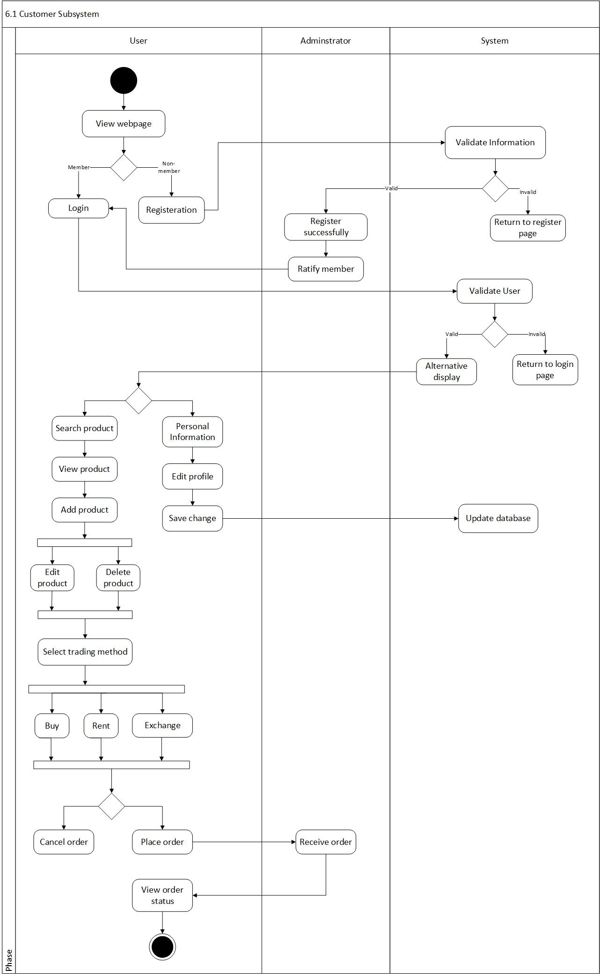6.1 Customer subsystem

­

6.2 Purchase order system

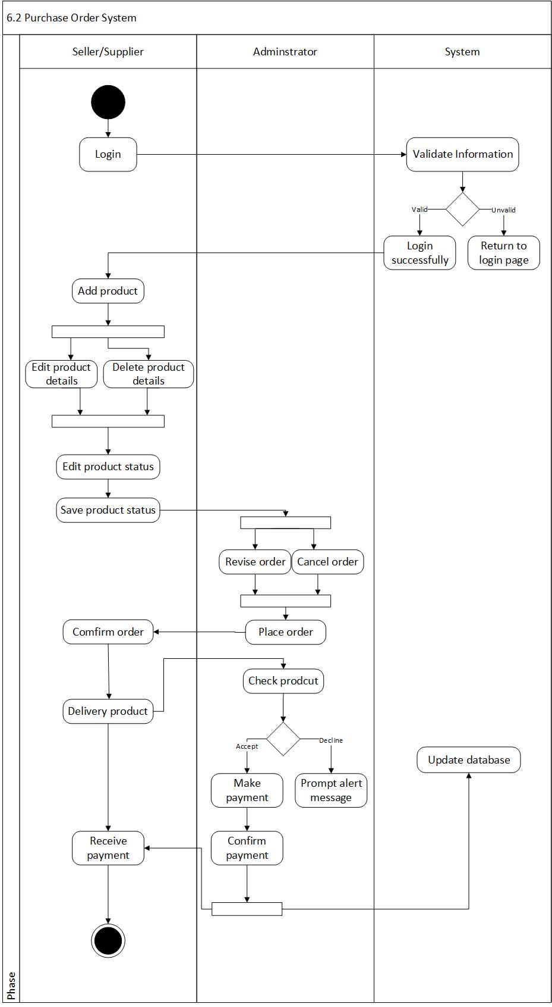

6.3 Payment 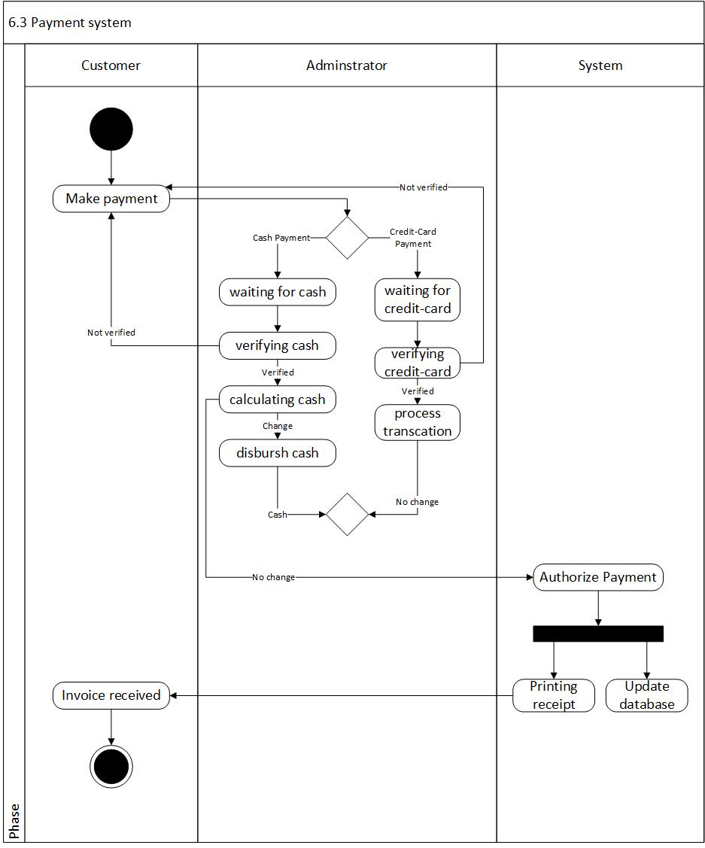system

6.4 Report system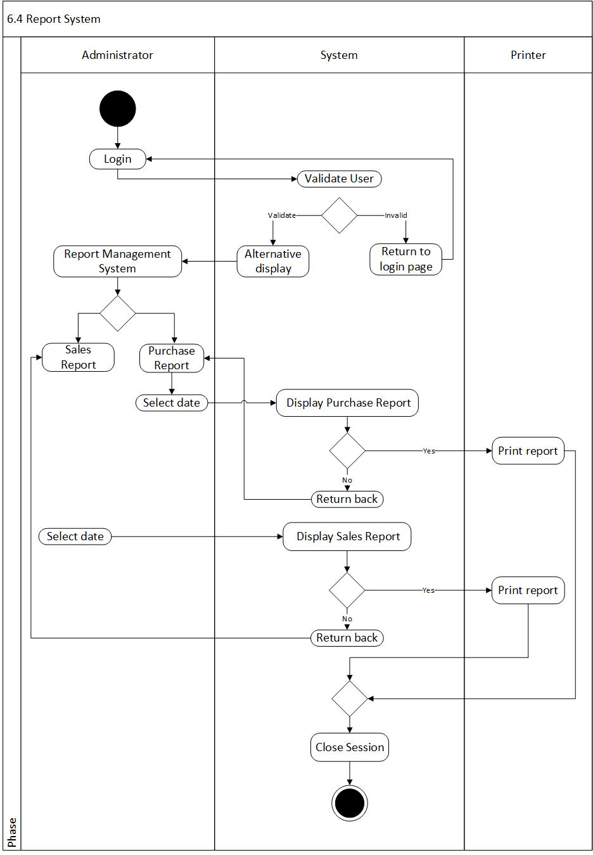

6.5 Sales order 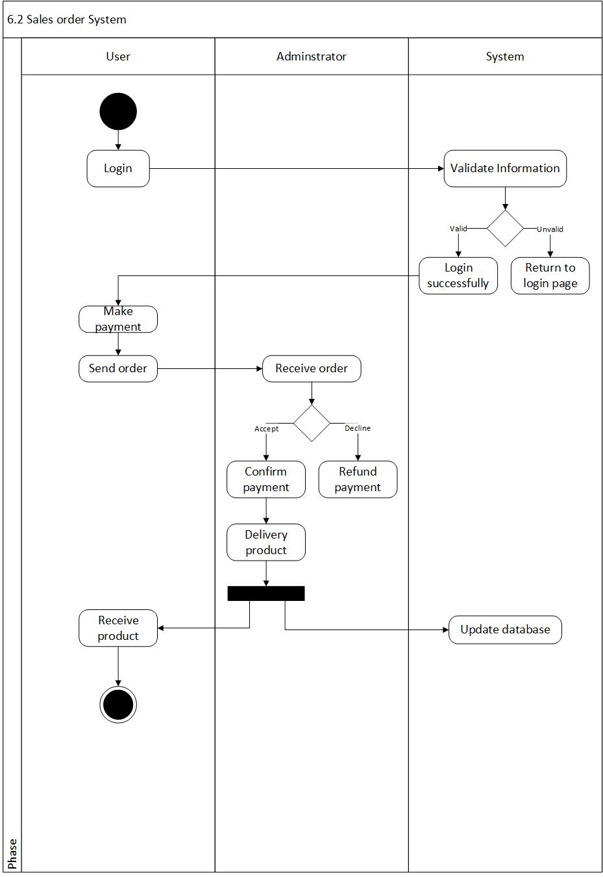system

6.6 Administrator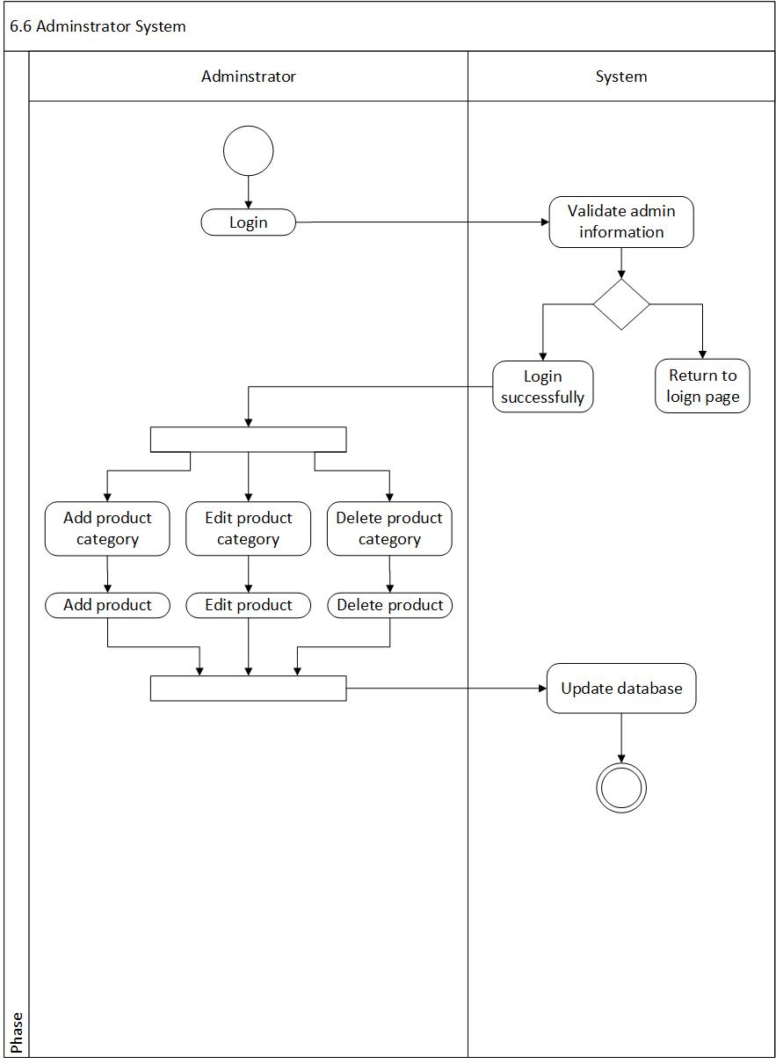 system

7.0 Sequence Diagram

7.1 Customer subsystem

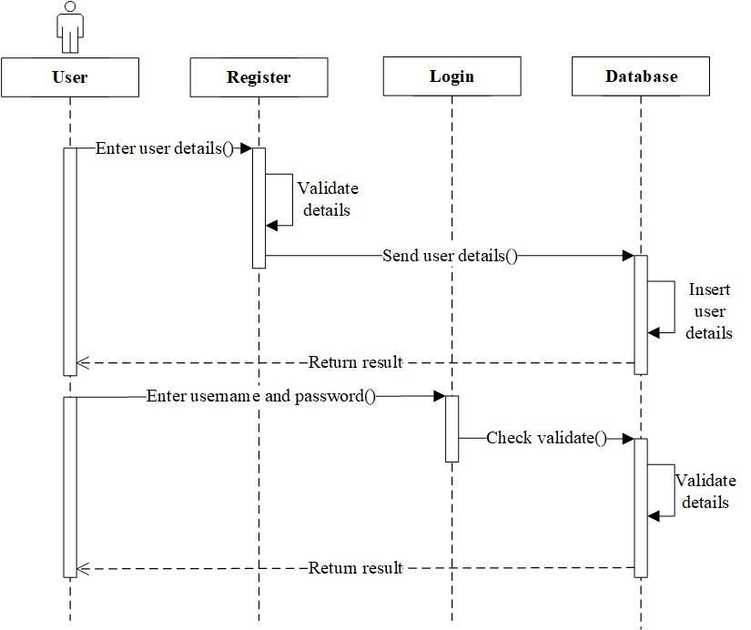

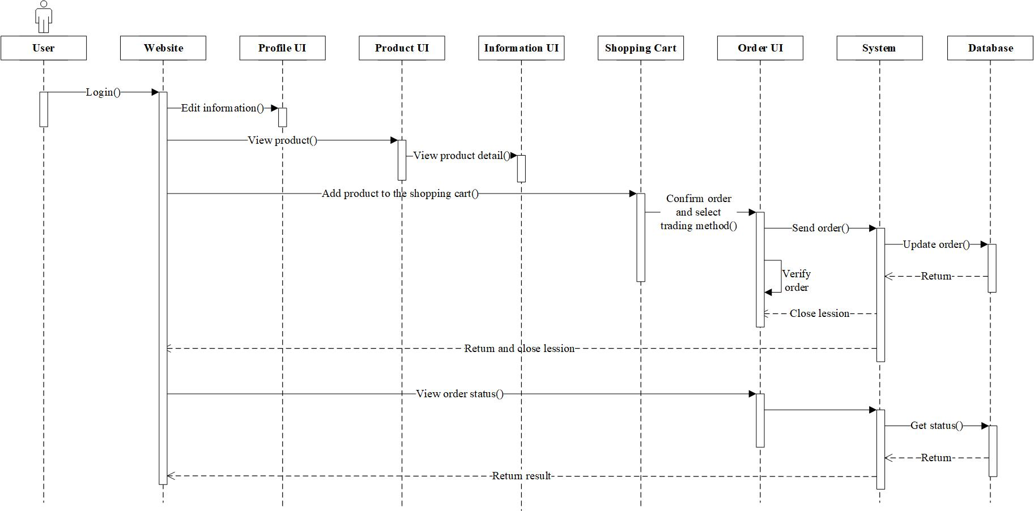

7.2 Purchase order system

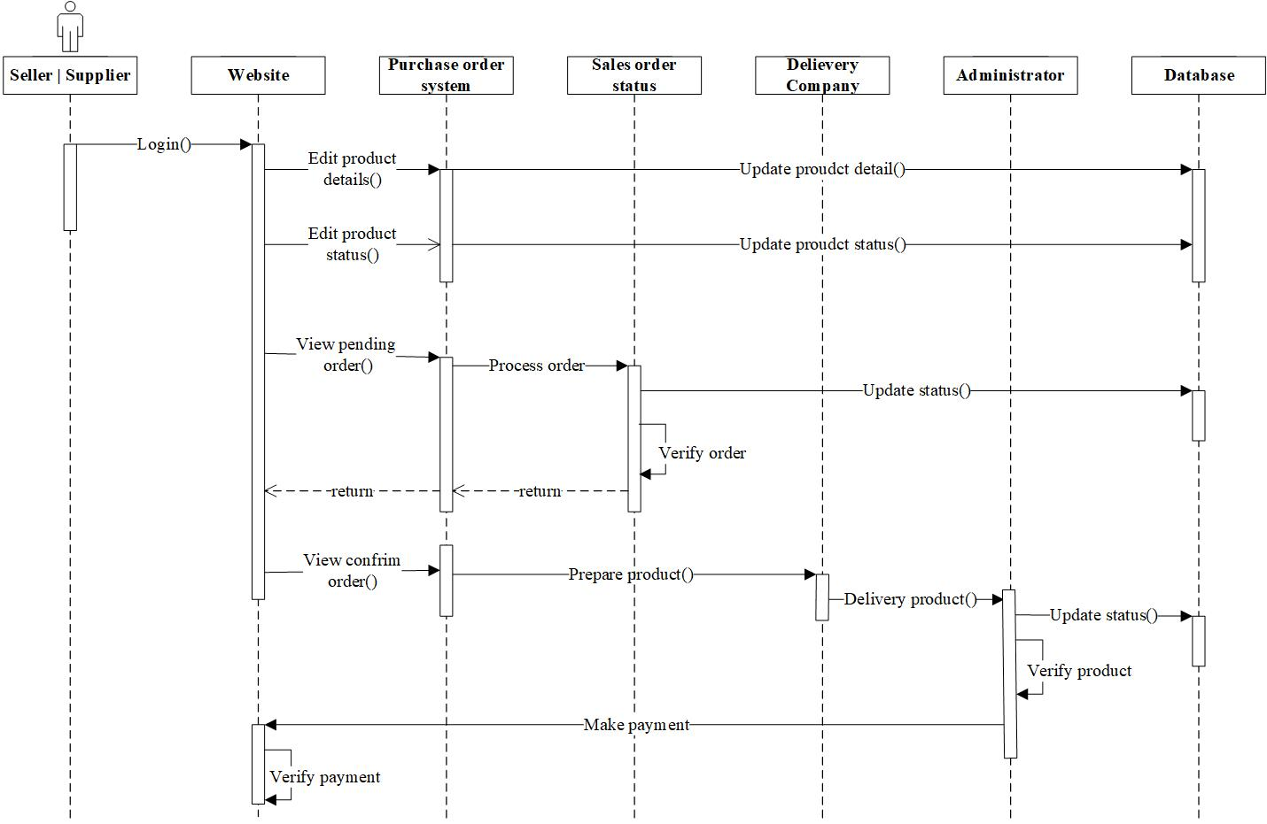

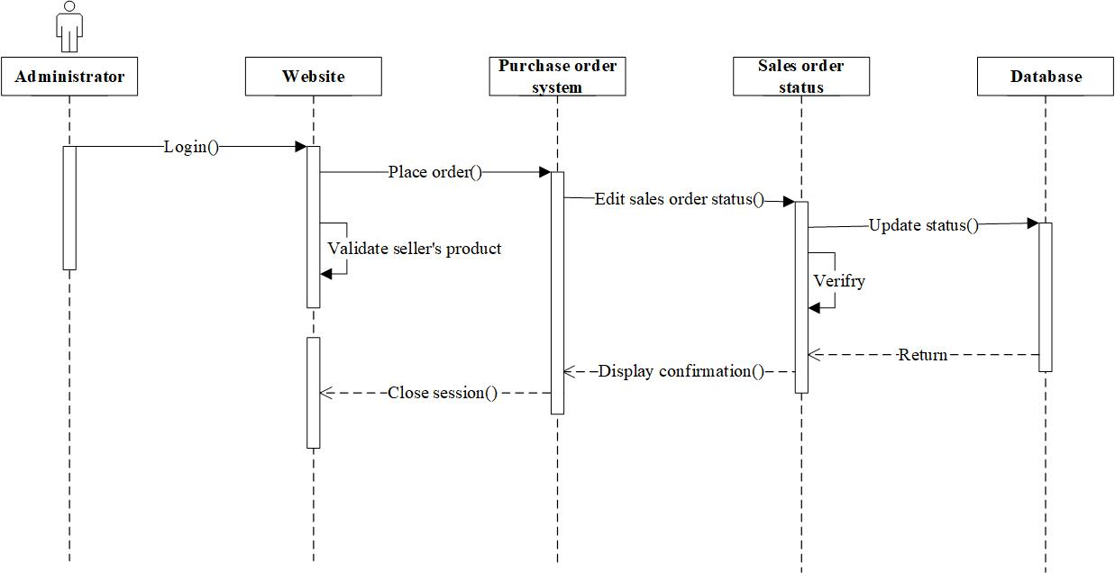

7.3 Payment system

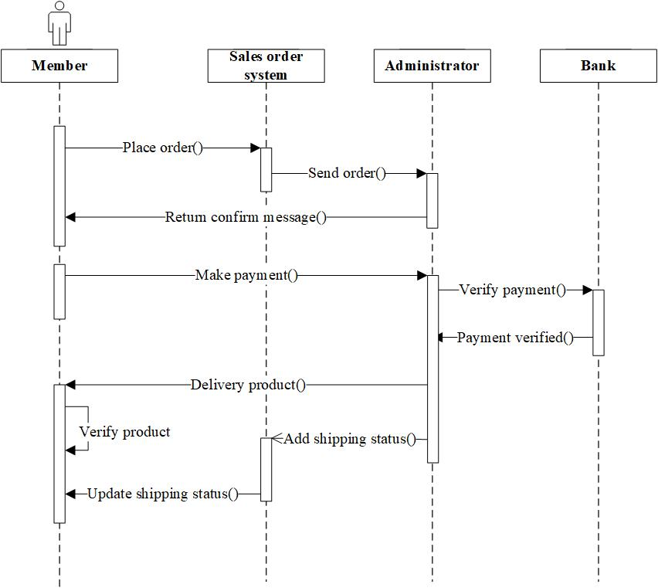

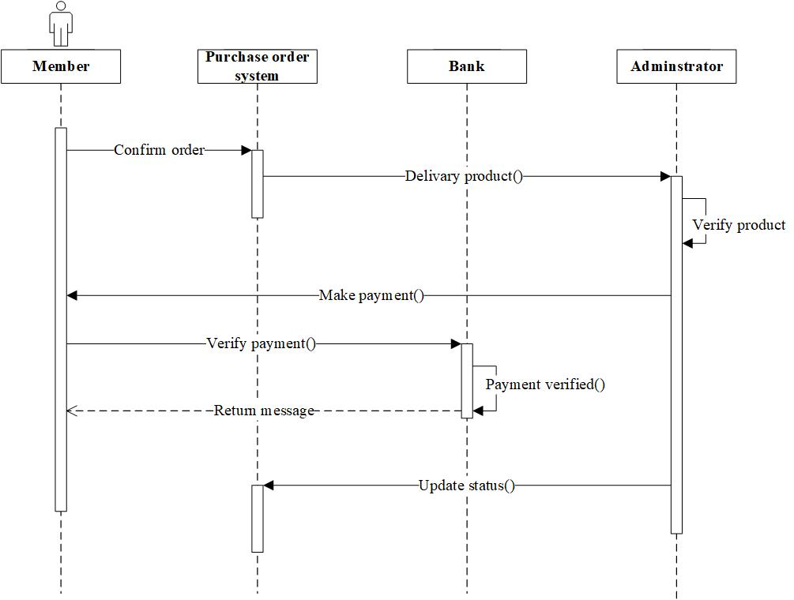

7.4 Report system

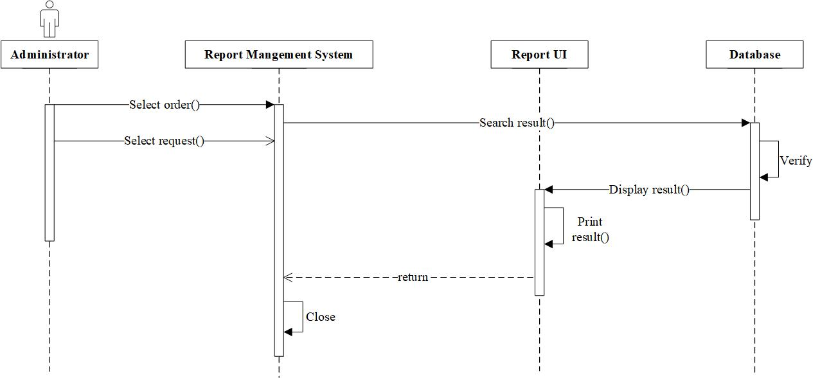

7.5 Sales order system

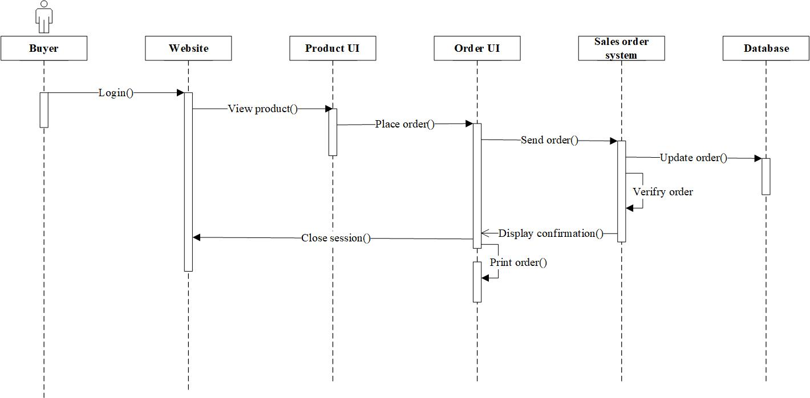

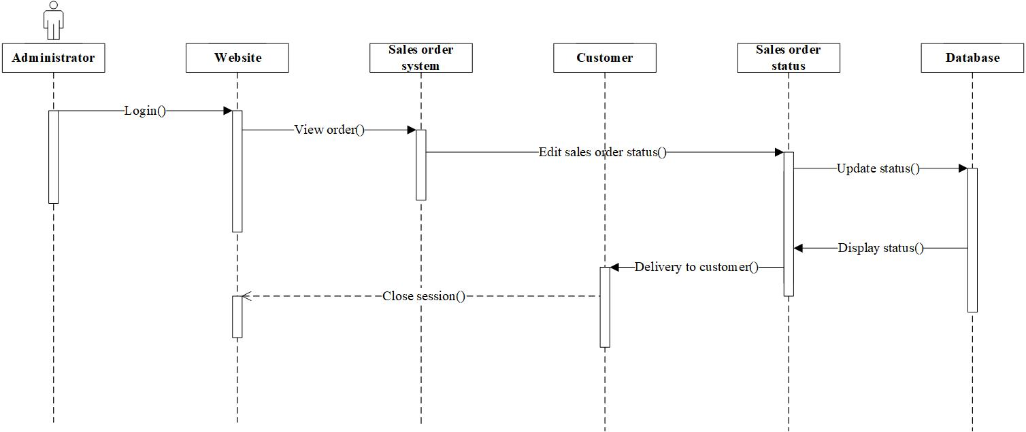

7.6 Administrator system

